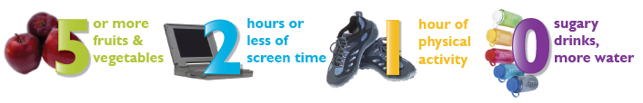

Activities Toolkit
Yellowstone County, MT

