Introduction
Members of the American Academy of Pediatrics (AAP) recommend no more than two hours per day of any type of entertainment screen time for children ages 3 to 18 and none for children 2 or younger. "Screen time" means television screens, computer monitors, and even the handheld devices we use for checking email, listening to music, watching TV, and playing video games. Screen time is a sedentary activity, often meaning you are sitting down, and or being physically inactive. Very little energy is used during screen time.” http://www.nhlbi.nih.gov/health/educational/wecan/reduce-screen-time/
According to Neil Kaneshiro, MD and clinical Assistant Professor of Pediatrics “Most American children spend about 3 hours a day watching TV. Added together, all types of screen time can total 5 to 7 hours a day. Too much screen time can raise a child’s risk of attention problems, anxiety, sleep disorders, and depression. Too much screen time can also increase a child’s risk of gaining too much weight, and potentially leading to obesity.” http://printer-friendly.adam.com/content.aspx?productId=117&pid=60&gid=000355&c_custid=758
For many of us, limiting our computer use and getting away from all screens can be a challenge (http://www.nhlbi.nih.gov/health/educational/wecan/reduce-screen-time/ ). The time we spend in front of the screen, unless it's work- or homework-related, could be better spent being more physically active (increasing our energy out). Limiting screen time opens up a world of possibilities for children! Most importantly it allows them to be active in many ways. Active children do things and limiting screen time helps develop healthy children. Research has shown that less screen time means more time to play, read, sleep, and engage in family meals and family events. We could all experience health (& quality of life) benefits through less screen time!

Two hours or less of screen time overview: In this section participants will learn more about the “2” two hours of less screen time in the 5-2-1-0 community health message through a variety of activities.
Two hours or less of screen time objectives:
- Identify strategies to minimize screen time
- The impact of too much screen time on health
- Understand how to read nutritional labels
Two hour or less screen time activities:
- Creating a 5-2-1-0 visual or poster displays
- Healthy By Design educational screen time
- Additional suggested activities
Two hours or less of screen time resources:
http://www.letsgo.org/wp-content/uploads/2Brochure.pdf
http://ourcommunityourkids.org/media/5272/5210-2%20Flyer.pdf
http://www.henryfordlivewell.com/2-hours-or-less-of-screen-time

Purpose: The purpose is to teach participant how to promote and share the 5-2-1-0 message by participating in an activity that reduces participant’s screen time.
Create a 5-2-1-0 visual and or poster (K-3)
Estimated duration time: 1 hour
Materials needed:
- Markers
- Crayons
- Coloring pencils
- Paper
- Scissors (assist depending on age group)
- Glue

Warm-up
Introduce the concept of the “2” hours of less screen time, connecting the activity to the 5-2-1-0 community message.

ASK participants: How much screen time do you have each day?
Ask participant to guess how many minutes or hours of television they watch each day?
How much home computer time?
How much time on video games?
How much on cell phones? Add up the numbers above.

Ask children to make suggestions on how they could spend that amount of time doing things they really enjoy (running, being with friends, reading, etc).

Create a 5-2-1-0 visual and or poster activity (K-6)
Create a poster illustrating what they will do instead of having _X_ amount of screen time. That is, how can they be more active and less sedentary?

Have children show their poster and explain how they are going to spend their time being active burning more calories instead of storing away calories and being a sedentary screen watcher?

If possible display the posters in a common hallway.

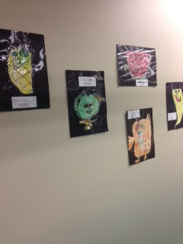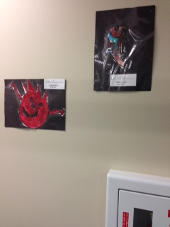
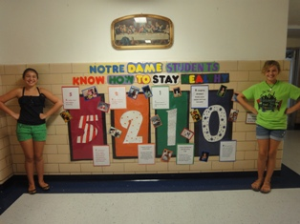
Create a 5-2-1-0 visual or poster displays resources
http://www.letsgo.org/news/great-example-of-how-anyone-anywhere-can-adopt-the-5-2-1-0-message-to-promote-healthy-eating-and-active-living/
Teach new group games or take time to jump rope, play tag, or skip around the room?
Check out these websites:
http://kidshealth.org/parent/growth/learning/school_age_games.html
http://www.parenting.com/gallery/18-fun-active-indoor-activities
http://www.todaysparent.com/family/parenting/20-fun-indoor-games/
http://www.ultimatecampresource.com/site/camp-activities/camp-games.html
Purpose: The purpose is for participants to learn the value of educational screen time and to become familiar with available resources through exploring the Healthy By Design website. Participants will be able to share this information with family and friends.
Healthy By Design educational screen time (Grades 4-6)
Estimated duration time 1: hour
Materials needed:
- Screen
- Projector
- Internet (connected to the computer)
- Computers
- Healthy By Design Website

Healthy By Design educational screen time (Grades 3-12)

Explain how educational screen time, time spent learning important information is a good use of screen time.

ASK participants: Do you know what Healthy By Design is? Have they heard about Healthy by Design in Yellowstone County?

Healthy By Design educational screen time activity (Grades 3-12)

Before sharing the Healthy By Design Website with participants visit and explore the website and familiarize yourself with the content on the web.

Visit HBD website, explore pages and have students present on what they have learned. Teach students how to use the resources available on the Healthy By Design website.
Wrap-up: Encourage students to share what they have learned in small group setting and with parents. Ask what things that might share with others about the website

Additional “2 hour of less screen time” activity ideas
- 5-2-1-0 you’ve got talent: pick your project
- k-3 (sing the song booklet) Media project, in folder
- 3-12 Allow students to create poem, song or a dance around the 5-2-1-0 message Give children the opportunity to write a poem or a song, or create a dance to illustrate either the 2 in 5-2-1-0 or the whole 5-2-1-0 message.
- Create posters, poems, songs about being active and not being sedentary and “watching” screens.
- Ask children to write a letter to their parents/guardians about how they want to be more active (no TV in bedrooms, no TV watching at meal times…) and how the child wants to involve the family.

