Introduction to Zero Sugar Beverages and More Water (5-2-1-0)
Did you know that most commercial sodas have no nutritional value? Many sodas contain 110-150 empty calories (calories from food with few or no nutrients) and contain caffeine, which is not an essential dietary need. Consuming excessive amounts of soda containing sugar could lead to overweight and put one at risk for developing a chronic disease, such as diabetes and obesity. Studies show overconsumption of sugar, including sugar found in beverages can lead to obesity. According to the 2014 Yellowstone County Community Health Needs Assessment, 32.6% of adults are obese, compared to 24.6% statewide. The number of obese youth in Yellowstone County is 28.7%, which is similar to the statewide trend
Water is essential, and is extremely vital. It is recommended. Between 70-80% of your body is made up of water. When you increase your level of activity your body often sweats, and when you sweat your body is releasing water and minerals it is important to replace the water your body uses
How about: Water is essential, and is extremely vital as cells are made up of 65-95% water. Sweating is a natural way for the human body to reduce heat accumulation, and sweat loss occurs from movement of water out of cells onto the body surface for evaporation. Thus to stay healthy and hydrated, we need to replace water on a daily basis.
Water is the #1 thirst quencher and it is often free!
Do you know these fun facts:
- A typical 20-ounce soda contains 15 to 18 teaspoons of sugar (that’s almost 22 packs of sugar!) and upwards of 240 calories. A 64-ounce fountain cola drink could have up to 700 calories.
- Drinking one or two sugary drinks each day increases the risk of type 2 diabetes by about 25%.
- Nearly 1 in 2 Latino children born in the year 2000 will get diabetes in their lifetime.
- Latino children saw one and a half times more ads for sugary drinks and energy drinks, and Latino youth saw twice as many ads.
- Generation Y (also known as the Millennial Generation born in the 1980s-early 2000s) will be the first generation expected to live shorter lives than their parents due to obesity and related diseases like diabetes.
- Sugary drinks are the number 1 source of calories in young people’s diets.
* All facts and sources can be found on Harvard School of Public Health’s website.

Zero sugary drinks, more water overview: In this lesson participants will learn more about the “0” in the 5-2-1-0 community message. More specifically, the health impact of consuming sugary beverages also known as “liquid candy” through participation of group activities and discussion. Sentence fragment change to:
Zero sugary drinks, more water:
- Gain knowledge about the harmful impact of sugary drinks
- Become aware of the amount of sugar contained in sugary drinks
- Identify strategies for less sugary beverages and water
- Look at the marketing of sugary drinks through use of http://www.sugarydrinkfacts.org/
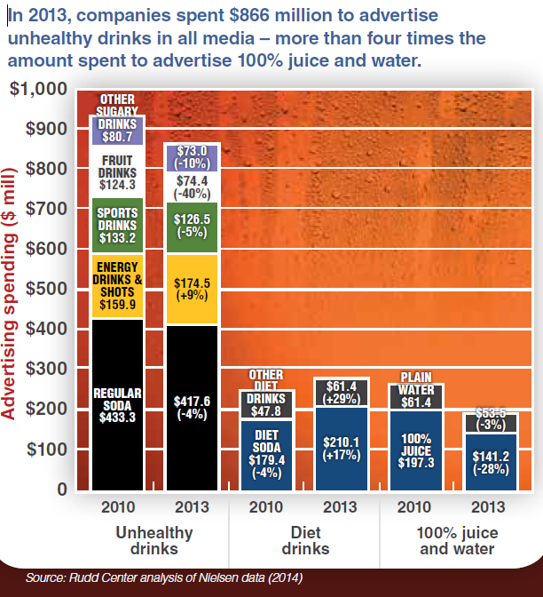

Zero sugary drinks, more water activities:
- Play Sugar drinks jeopardy
- Rethink your drink—how much sugar is in your favorite sugary beverage? Look at food labels either online or from a variety of examples brought to class.
- Create a sugar display using cubes of sugar that are stacked to match to food label of sample beverages. (okay this appears later on page 6-7)
- Zero sugary drinks, more water public service announcement (PSA)

Zero sugary drinks, more water resources:
Liquid Candy: how soft drinks are harming Americans health
http://www.cdc.gov/mmwr/preview/mmwrhtml/mm6332a2.htm?s_cid=mm6332a2_e

Purpose: The purpose of this activity is increase participants knowledge on zero sugary drinks and the value of drinking more water.
Sugary drinks jeopardy activity (Grades 3-6)
Estimated duration time: 30-45 minutes (per game)
Materials need:
- Internet (for Jeopardy game)
- Online jeopardy instructions
- Pen
- Paper

Warm-up Introduce the concept of the “0” sugary drinks more water, connecting the activity to the 5-2-1-0 community message.

Challenge participants to think about the last time they had a sugary drink during the week (all things including juices containing sugar counts.

ASK participants: to create a list of all the sugary drinks during previous day. Also ask them about their water consumption—be careful these drinks contain water.

Click here for additional instructions about online jeopardy games.

Sugary drink jeopardy activity
Select the jeopardy game you want the group to plan.

Sugary Jeopardy 1
Sugary Drinks Jeopardy 2
Explain: The purpose of the jeopardy game connecting it back to the “0” sugary drinks and beverages.

Wrap-up discussion: plan to use the information to make healthier decisions?

Purpose: The purpose of this activity is to use the zero in the 5-2-1-0 community messaging to increase awareness about the sugar content in drinks and to brainstorm strategies to consuming more water.

Rethink your drink—how much sugar is in your favorite sugary beverage? (Grades 4-12)
Total duration time: 1 hour
Materials needed:
- What are you actually drinking infographic?
- computer and internet
- pen
- paper
- markers
- and crayons
- dry erase board markers
- poster board materials

Warm-up Introduce the concept of the “0” sugary drinks more water, connecting the activity to the 5-2-1-0 community message.

ASK participants: What is your favorite drinks are their favorite sugary drink is? Share with participants What are you actually drinking infographic?

Introduce the activity by helping participants identify sugary drinks. Allow them to share each beverage and then vote for the top three choices. Keep a tally of the top three choices listed on the board (this is scalable and size will vary depending on class size.

Once you have identifed the top three choices assign participants to a beverage and create a 5 minute presentation on sugar content of their favorite drink. The presentation should include information on the product, brand, and number of grams of sugar.

Share what they have learned about the sugar contained in each drink with the rest of group and how they might plan to change their drinking habits.

Rethink your drink—how much sugar is in your favorite sugary beverage?
http://d3n8a8pro7vhmx.cloudfront.net/foodday/pages/8864/attachments/original/1393262600/Infographic_for_Feb_26_e-mail.pdf?1393262600
http://d3n8a8pro7vhmx.cloudfront.net/foodday/pages/8864/attachments/original/1393262600/Infographic_for_Feb_26_e-mail.pdf?1393262600

Purpose: The purpose is to create a sugar display teach participants how increase health awareness using the zero in the 5-2-1-0.
Create a Sugar display (Grades 4-12)

Estimated time duration: 1-2 hours on average, time will vary depending on display and number of participants.
Materials: sugar (cubes or granulated) containers
- scale, measuring cups
- measuring spoons
- sugary drink empty bottles,
- markers
- writing utensil poster board for display
- white board camera for taking pictures
*The materials will vary depending on the type of display you want the group to create.
Sugar display 1 instructions and Sugary Display 2 instructions
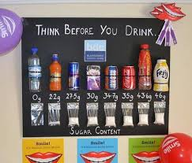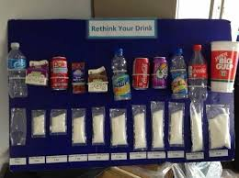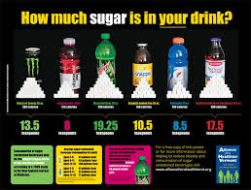
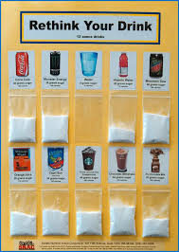
Warm-up Introduce the concept of the “0” sugary drinks and more water, connecting the activity to the 5-2-1-0 community message

Challenges participants to think about what their favorite drink is and have them writing it down.
ASK participants: Next ask them to write down the amount of sugar they think is contained in their favorite beverage and collect the responses. How do the sugary drinks compare to water. Read the response out loud and keep tally of the most popular drinks on the board.

Create a sugary display activity

Share more sugary beverage facts

Create a sugar display: Create one of the identified sugar displays, this can be done in groups of 2-3 or as one whole group depending on available supplies and resources.

Select a sugar display, and review instructions:
- Sugary Display 1
- Sugary Display 2

Take pictures of the display and send to Healthy By Design Coalition and other community organizations; help promote the message and share the public health action around the 5-2-1-0 community health message.

Wrap-up discussion: Ask participants to identify the ways they would like to share the zero sugary drinks and more water using the display(s) they created. Identify opportunities where participants can share the information within the community.

Create a sugar display resources http://www.foodday.org/how_much_sugar_are_you_drinking?utm_campaign=how_much_sugar&utm_medium=email&utm_source=foodday
http://www.letsgo.org/wp-content/uploads/ASTab03D04-Make-Your-Own-Sugar-Bottle-Display-Tab-6-COLOR-DOUBLE-SIDED.pdf
http://www.letsgo.org/wp-content/uploads/ASTab03D04-Make-Your-Own-Sugar-Bottle-Display-Tab-6-COLOR-DOUBLE-SIDED.pdf
https://www.google.com/search?q=sugary+drinks+display&es_sm=122&tbm=isch&tbo=u&source=univ&sa=X&ei=QPXsU5XZCeLMiQKj5oGQDA&ved=0CB4QsAQ&biw=1366&bih=583

Purpose: The purpose is to teach participants how to create a media campaign around a community call to action around obesity epidemic. Participants will use what the know about the harmful impact of sugary including the sugar contained in sugary drinks to create a PSA, or media, campaign or video around promoting the “0” sugar drinks, more water.

Zero sugary drinks, more water PSA!
Estimated duration: 1 to 2 hours (several sessions)
Materials needed: materials will varied depending on available materials and resources.
- White board
- Pen
- Markers
- Crayons
- Internet
- Poster board
- Computers
- Sample Sugary drinks poster and walking off sugary drinks poster (PSA)/advertisements (11x17)
- Sugary drinks fact sheet (top of page)
- Sugary drinks videos (bottom of the page)
- CDC rethink your drink

*Before getting started review Toolkit: sugary drinks and determine what kind of PSA want participants to create!

Warm-up
Introduce the concept of the “0” sugary drinks more water, connecting the activity to the 5-2-1-0 community message if you have not already done so (for those who decide to not use all activities or view them in order).

Ask participants: How many grams of sugar does a 20 ounce bottle of soda contain? Ask them how many of packs of sugar do they think it contains (about 16 packs)

Use the Toolkit: sugary drinks and listed resources (below) to have a conversation around the harmful impact of sugar and how it is linked to obesity.

Explain the group activity, break participants into teams. Explain the instructions having the students use the fact sheet handouts and resources to create a PSA around the zero sugar drinks more water. Let participants know the top 2 PSA will be used and shared with the community (option).

Listen: All participants share their PSA with the group. Also allow participants to vote on the one they would like to adopt and share with the community (optional).

Wrap-up discussion: Ask participants to share with them have learned, and identify specific groups within the community they would like to share the PSA. Make sure to share the PSA work with Healthy By Design!

Zero sugary drinks, more water resources
http://www.multco-itstartshere.org/links-and-resources/toolkit-sugary-drinks Suggest that participants make their own local poster similar to the ideas shown here on walking off the calories.
http://www.cdc.gov/nccdphp/dnpa/nutrition/pdf/rethink_your_drink.pdf
http://www.cutsugarydrinks.org/en/resources
http://boston.cbslocal.com/2011/08/31/first-of-its-kind-cdc-report-breaks-down-soda-statistics/
http://www.foodday.org/too_much_sugar?utm_campaign=sweet_act&utm_medium=email&utm_source=foodday

The take home message that is essential for children to learn is that sugary drinks do not provide much nutrition; just “empty” calories. Thus it is very easy to put too many calories into the day’s bank account without burning them off (remind them that calories are required to fuel their bodies, but if they consume too many they will be stored as fat).

