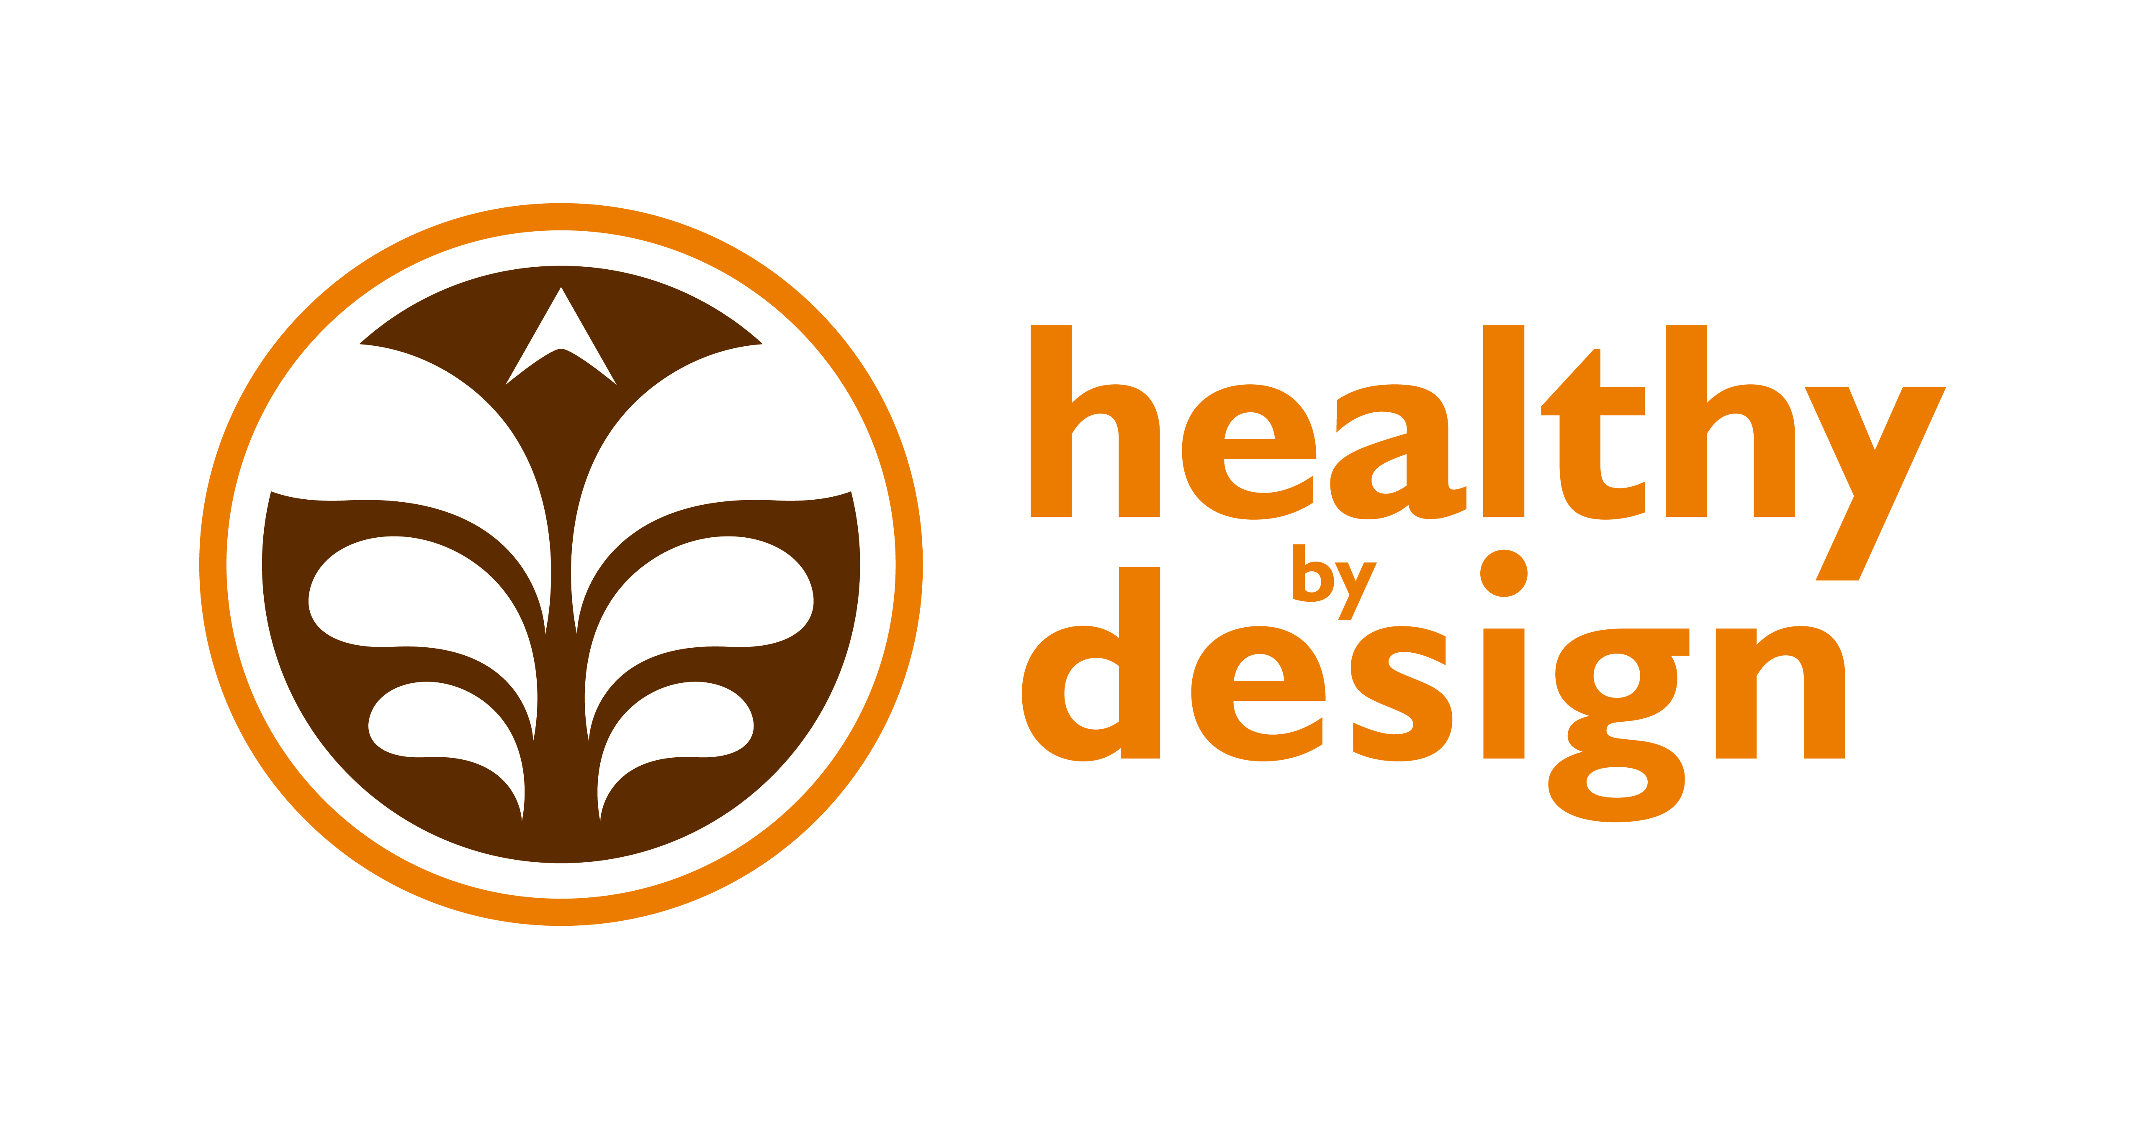

Coalition

Creating a Community that is Healthy By Design

August 7, 2012 Meeting Minutes

Attending:

Alyssa Auvinen: RiverStone
Health
April Keippel: St. Vincent Healthcare
Barbara Schneeman: RiverStone Health
Bruce MacIntyre: Chamber of Commerce
Debra Hagel: MET Transit
Hannah Miller: RiverStone Health
Hillary Hanson: RiverStone Health
Katie Kirkpatrick:
Laura Holmlund: RiverStone Health
Ron Wegner: MET Transit
Sara Hudson: Big Sky Economic Development
Sara Rehmer: RiverStone Health
Shawn Hinz: RiverStone Health
Tina Postel: Billings Family YMCA
Tori Kidgell: RiverStone Health
Tracy Neary: St. Vincent Healthcare

Announcements:

- New to HBD – Sara Rehmer and Hannah Miller from RiverStone Health. Sara will be co-leading the Recognition Program workgroup and Hannah is the new CDC associate. She will work for one year with HBD and the second year with Family Health Services.
Bruce: 1) Red Cross is looking for 1,000 square feet of free space for firefighters working forest fires. If you know of any available space contact Keri at the Chamber.
Tina: 1) Color me Rad 5K Run is October 27th at Metrapark, presented by the same people that do the Dirty Dash but geared more towards family. The race benefits the Billings Family YMCA. Use promo code "YMCA" and 20% of your registration fee goes to the Billings Family YMCA. Register at: www.colormerad.com.
Tracy: 1) Over the Edge is taking place on August 23rd. Fundraisers rappel 19-stories from the roof of the First Interstate Bank Tower to benefit Special Olympics.

Discussion:

- Co-leads introduced themselves, their workgroup topic, the workplan, and answered questions.

- Worksite Wellness – Alyssa Auvinen & Tracy Neary
  - Support work environments that are Health By Design
  - Using Tool Kit piece
  - Find businesses that are willing to commit to Healthy By Design
  - Working with Chamber
  - Will be doing a group presentation on August 29th for the Billings Wellness group

- Healthy Weight – Alyssa Auvinen & Elizabeth Ciemins
- Capitalize on grant work from previous year – Get the 5-2-1-0 message out
- Been focusing on primary care providers, want 5-2-1-0 to be a community focus
- Going to use school nurses to get 5-2-1-0 message into the schools
- Also want to eventually do BMI measurements in the schools

- Health Equity – Shawn Hinz & April Keippel
- Gardner’s Market
  - Every Thursday from 5-7pm in RiverStone Health’s east parking lot
  - Need to look for marketing opportunities
  - Will focus on marketing in the fall and spring
  - Need to target groups that need fruits and veggies
  - Applying for a grant to have a community garden
- Women’s Health – increase physical activity for women in Yellowstone County
- Workgroup meeting Tuesday, Aug. 28th, 1:30-3pm, Madison/Jefferson room at St. V’s

- Built Environment – Laura Holmlund & Hillary Hanson
- Passed Complete Streets policy
- Need to be sure we are implementing this in the community
- Health, Safety, Economics
- Goal is to build a user-friendly public report with data on it that exists from year to year

- Recognition Program – Sara Rehmer & Luke Kobold
- Continue recognizing events that apply for Healthy By Design
- Explore ways to encourage events to re-apply each year
- Extend recognition to caterers and restaurants in the community that are Healthy By Design

- Workplans serve as a guidance tool. Gives us an opportunity to apply for both small and large grants. Also gives us the ability to share HBD within our organizations as well as with outside ones. In addition, we are able to involve the entire community in HBD.
- Plan for materials to be available at www.healthybydesignyellowstone.org
  - Other workgroups and public will have access to our plans
  - Holds us accountable
  - Workgroups meet separate from the Coalition
- HBD partners, please give thought to which work group(s) you’d like to join, if any, and let Sara know so she can put you in touch with the appropriate Team Lead.
- Coalition meetings will be held quarterly going forward.

There will be no meeting in September.
Next Coalition meeting: Tuesday, November 6th from noon-1:30pm in the Yellowstone Room of the Lil Anderson Center at RiverStone Health.

