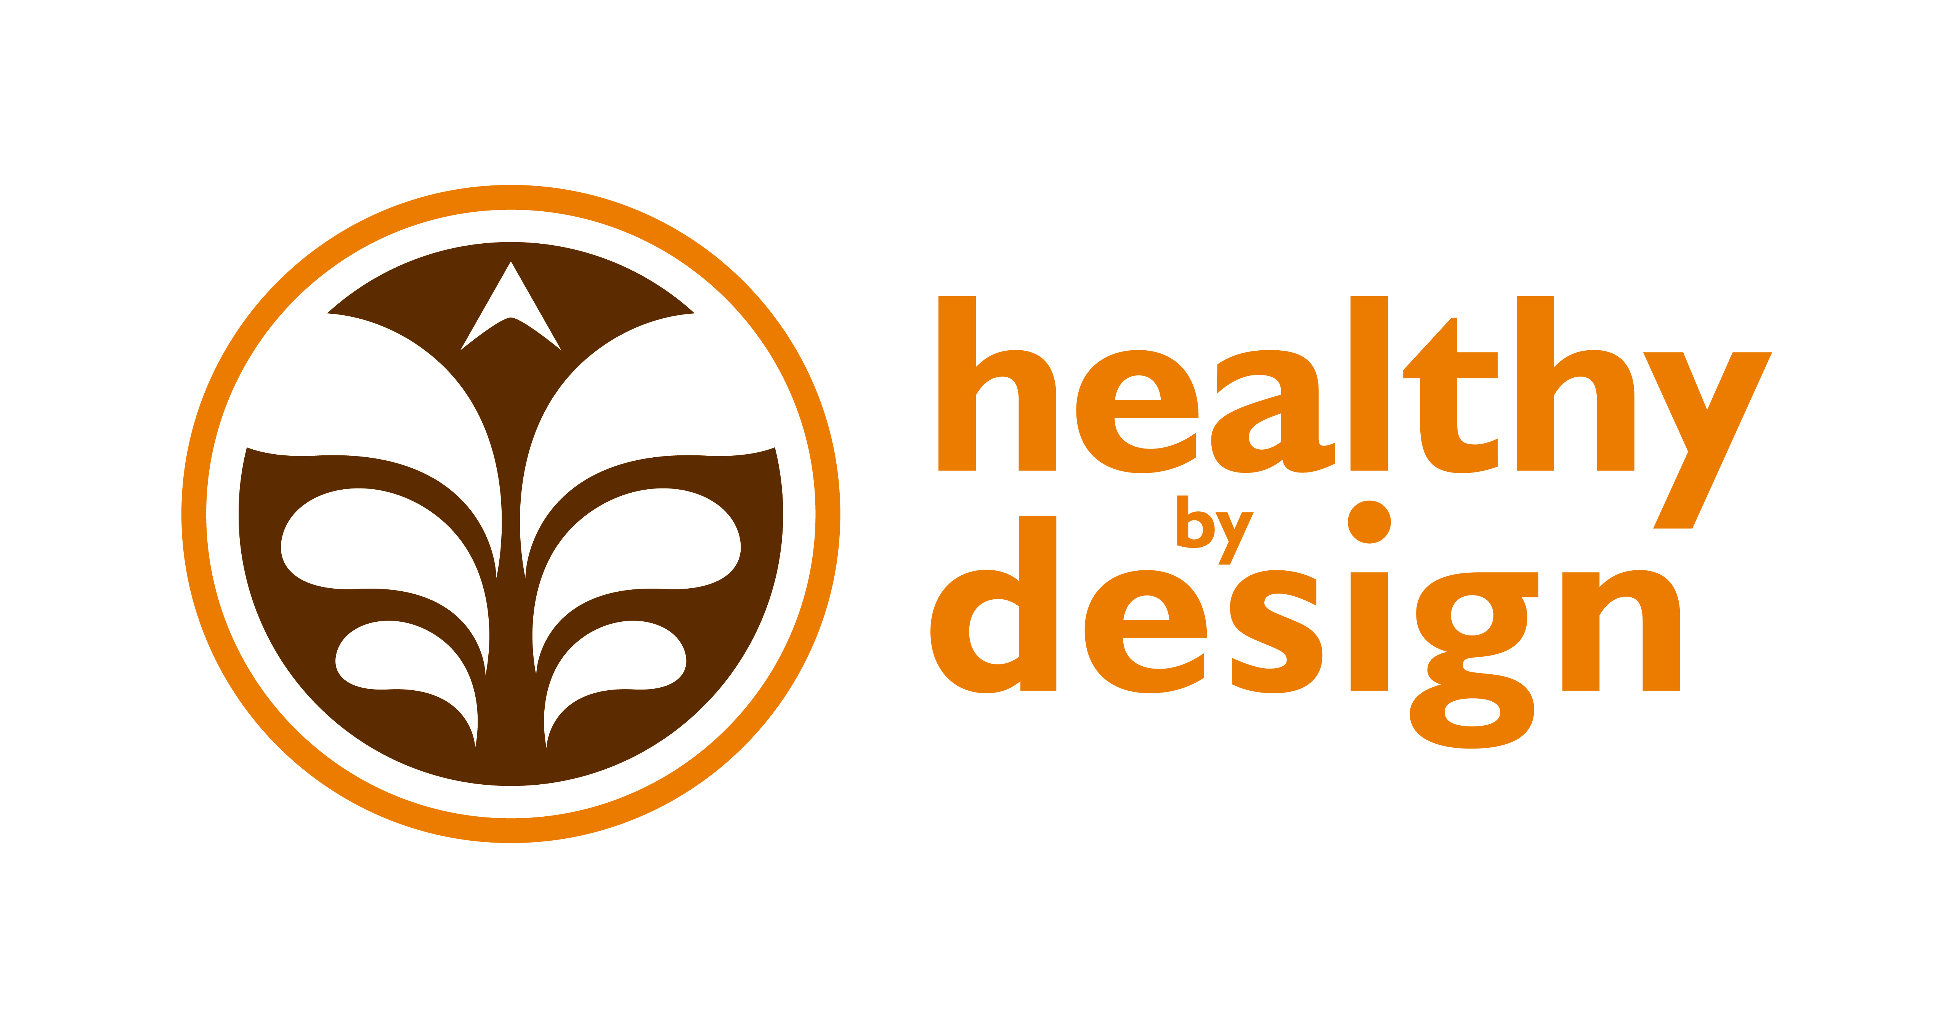

Coalition

Creating a Community that is Healthy By Design

February 5, 2013 Meeting Notes

Attendees:

Alyssa Auvinen: RiverStone Health
April Keippel: St. Vincent HealthCare
Arianne Snyder: Billings Clinic
Chuck Barthuly: Better Billings Foundation
Colin Dow: St. Vincent Healthcare
Darlene Tussing: City-County Planning
Dayle Hayes: School Meals that Rock
Debra Hagel: MET Transit
Ginny Mermel: School Health Advisory Council
Glenda Sprankel: St. Vincent Healthcare
Hannah Miller: RiverStone Health
Hillary Hanson: RiverStone Health
Jeanne Manske: Billings Clinic
Karen Sanford Gall: Big Sky State Games
Kristi Conroy: St. Vincent Healthcare
Lainey Reynolds-Keene: Keene Insight
Laura Holmlund: RiverStone Health
Lori Heimbichner: Crowley Fleck
Lorraine LaFurge: RiverStone Health
Ron Wenger: MET Transit
Sara Rehmer: RiverStone Health
Shawn Hinz: RiverStone Health
Shaye Skovgaard: MSUB Extension Office
Shelley Hayes: Billings Clinic
Suzie Eades: Q360 Health
Tina Postel: Billings Family YMCA
Tracy Neary: St. Vincent Healthcare

Announcements:
- Lorraine (RiverStone Health) will take over Tori Kidgell’s HBD duties
- Ron (MET Transit) Looking for Billings champion to promote Ride Share MT (www.RideShareMT.com) – bring ideas to next meeting
- Suzie (Q360 Health) Opened own health & wellness coaching business
- Karen (Big Sky State Games) Shape Up Montana & Big Sky Fit Kids started February 1st (www.bigskystategames.org); 7 of the 30 Fit Kids Clubs are Billings schools – provides 90 additional minutes of physical activity
- Dayle (School Meals That Rock) Like us on Facebook!
- Tracy (St. Vincent Healthcare) Walk & Talk with the Doc, Tuesdays at 5:30pm – meet in the YMCA lobby, it’s FREE!
- Alyssa (RiverStone Health) Gardeners’ Market vendor information available – need to plant seeds now (http://www.healthybydesignyellowstone.org/initiatives/gardenersmarket/)
- Chuck (Better Billings, Oasis) 100,000 visitors to the Oasis last summer – selling season passes
- Tina (YMCA) Offering new class on how to read nutrition labels
- Arianne (Billings Clinic) February is Heart Health Month – CPR Saturday is February 16th (www.cprsaturday.org)
- Darlene (Planning) Bike Walk Summit is March 15th in Helena – Lt. Gov. John Walsh will be keynote speaker

Discussion:
- Recognition Program Workgroup – Luke Kobold & Sara Rehmer
  - Review Team meets quarterly right before the Coalition. This meeting discussed: 1) creating a document that allows events to display what they did differently from other events to address safety, physical activity, nutrition, environmental stewardship, and prevention/overall wellness; 2) Incorporating 5-2-1-0 messaging in collateral material; and 3) creating a “best practices” HBD recognition application to post on the website as an example for others
  - Reminder: we are all ambassadors of HBD – please encourage event planners in your organization to apply for recognition (http://www.healthybydesignyellowstone.org/apply/)
- Healthy Weight Workgroup – Elizabeth Ciemins & Alyssa Auvinen
  - Free Motivational Interview training April 26th open to healthcare providers, seating is limited – visit HBD webpage under “training” on right-hand side
  - Kim Fischer (RiverStone Health) is a diabetes educator that has joined the group, she is great at health focused presentations – helped with a 5-2-1-0 message day that reached 300 kids
  - Looking to brand workgroups with 5-2-1-0 message, “community message” has broad effect, organizations could consider adopting/incorporating message (MET Transit is going to put poster in busses, YMCA is going to display a banner, Big Sky State Games is going to distribute magnets), 5-2-1-0 collateral material is available – contact Alyssa at alyssa.auv@riverstonehealth.org if you’d like any
  - Reminder: 5-2-1-0 stands for 5 or more fruits & veggies, 2 hours or less of screen time, 1 hour of physical activity, 0 sugary drinks & more water
- Built Environment Workgroup – Hillary Hanson & Laura Holmlund
  - Community Transportation Enhancement Program (CTEP): 600 surveys completed, results are being compiled, an RFP has been sent to a design company for a spring and fall user-safety campaign – the theme is “be aware of rules of the road” targeting all users and educating them on how to use infrastructure
  - Complete Streets policy adopted in August 2011 – working on benchmark/implementation report, goal is to complete it by early summer, there are issues re: looking at data over time and impact on community, this report may allow us to receive national recognition as there is currently nothing on how to implement and follow up
- Worksite Wellness Workgroup – Tracy Neary & Alyssa Auvinen
  - Working on getting businesses to adopt physical activity and/or nutrition policies, sample policies are on the website, biggest gap is tracking these policies – consider adopting one in your organization
  - Did outreach at SafetyFest, more scheduled with Rotary Club (Downtown & West End) and SHRM
  - The state offers incentives for working on these policies – Billings Clinic, RiverStone Health and St. Vincent Healthcare all received funding, trying to align their policies as much as possible
  - YMCA received incentive for nutrition policy and used the website to implement – could be used as a success story
  - Resources: Healthy Catering – Choose This Not That, provides local places
  - RD intern joined team (through August), working on getting info
- Health Equity Workgroup – April Keippel & Shawn Hinz
  - Gardeners’ Market
    - Market increases access to fresh fruits and veggies
    - Due to feedback and planning, some new changes will be made, promotion will be increased
    - This year’s market: June 13-October 3, RiverStone Health parking lot, hoping to have demonstrations, need volunteers
    - Received USDA grant, intern for a couple of weeks, promotion to consumers
    - Will take donations but will sell them because it create problems for other vendors last year
  - Office on Women’s Health Project
    - Increase physical activity in women: 1) research component – retention low, feedback and redesigned, 2) getting ready to re-launch active living curriculum, small changes that ad up, recruiting, 3) social marketing, 5-2-1-0, profile successful participants, how they did it
    - Needing facilitators and participant (10-20)
    - Looking for opportunities for outreach, additional members for community advisory group
    - Thought already established groups would do better because of the social supports but there were mixed results
    - Target population was minority and low SES (those who are more at risk), but doing more broad community focus now
  - Communications
    - Reps at workgroup meetings, more organized efforts, resources available, anyone can get plugged into workgroup if not involved
  - CHIP
    - Community Health Improvement Plan, formerly PITCH – “workplan” how we meet priorities (established by CHNA), back in cycle time, meeting to determine process, used vendor to split $55,000 cost, how should we do it now that it’s required for alliance?
    - Feedback: happy with it so far, not everything has been solved, like direction (physical activity and nutrition), 3 years is too short but hope to see movement, great resource for grants, want it consistent from year to year
    - Further questions: 1) Do we want to keep comparable data every 3 years; 2) Do we need to look at whole new structure? We could use trending data but set us up better in future
    - Partners need breakdown of minority and low SES – see the full report on HBD website or ask Tracy or Jeanne for information
    - There are questions Built Environment want but they must be health focused so that’s a challenge to incorporate them in
    - Contact HBD if you have further input

Next Coalition meeting: Tuesday, May 7th from 12:00pm – 1:30pm in the Yellowstone Room of the Lil Anderson Center at RiverStone Health.

