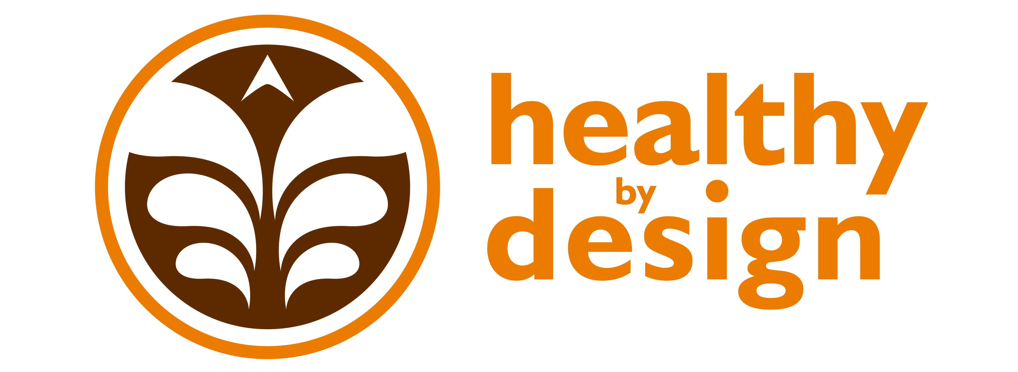

Coalition Partners

Creating a Community that is Healthy By Design
______________________________________________

August 6, 2013 Quarterly Meeting Notes

Attendees:

Alyssa Auvinen: RiverStone Health
Chuck Barthuly: Better Billings Foundation
Kristi Drake: BikeNet
Laura Holmlund: RiverStone Health
Sara Hudson: Big Sky Economic Development
April Keippel: St. Vincent Healthcare
Bruce MacIntyre: Chamber of Commerce
Jeanne Manske: Billings Clinic
Ginny Mermel: School Health Advisory Council
Barbara Schneeman: RiverStone Health
Hannah Silveus: RiverStone Health
Liana Susott: Big Sky State Games
Ron Wenger: MET Transit

Announcements:
Barbara – RiverStone Health is hiring two Outreach and Enrollment Specialists to assist with the implementation of the Affordable Care Act. They will be able to provide community assistance and answer questions about healthcare reform.
Liana – Big Sky State Games 2013 had approximately 10,000 athletes, 37 sports, and 2,000 volunteers.
Ginny – Please attend the End Childhood Hunger Conference in Bozeman September 23-24. Participants will come from Montana as well as out of state. The conference objective is to share best practices and develop action plans to take back to our communities.
April – Walk for the Poor, September 28, will be held in the downtown area and will benefit St. Vincent De Paul.
Sara – A group of Huntley residents are seeking Community Development Block Grant funds for affordable housing so seniors can age in place within that community.
Ron – MET Transit launched new route schedules August 1. Student passes for MET Transit are available for $10 for a limited time. Also, this fall, City-County Planning is working with a consultant and the public to develop the Long Range Transportation Plan looking out for the next 20 years. The plan will consider active transportation (for possibly the first time). Community members are encouraged to attend public meetings to support including active transportation in the plan. See www.billingslrtp.com for updates on the process and to get involved.
Jeanne – The community health needs assessment (CHNA) will now take place every 3 years. This fall PRC will conduct phone interviews and the Alliance organizations will conduct community member focus groups. If you receive a call to complete the phone survey, please participate! Also, the new HBD Community Health Improvement Coordinator has been hired and will be announced later this month.
Bruce – The Billings Chamber of Commerce is actively negotiating and working to connect the trail system. There is difficulty obtaining easement in the south portion of the eventual 26-mile loop. Also, Family Services, Inc is seeing an increased demand for their services/food boxes.
Kristi – There has been a spike in the number of bikes stolen in Billings. Register your bicycle with the City so it can be returned to you if stolen and recovered. Also, BikeNet’s goal for Ales for Trails 2013 is 3,000 attendees. The annual event will be held at Dehler Stadium on Sept. 27. Corporate sponsors are being sought for the event. Contact Kristi if interested!
Chuck – The Better Billings Foundation will host its annual Flip Flops and Fancy fundraiser on Sept. 6. Tickets are available. The Foundation has sponsored 28 underprivileged families to use the Oasis this summer. They are also doing a Park to Park Program with children living in the South Side of Billings; this program is attached to a reading assignment program.
Laura – Hilllary will be leaving RiverStone Health at the end of August for a position in Kalispell. Shawn Hinz will take her position on the HBD leadership team. Also, workgroup co-leads will be shifting and changing over the next couple of months. Stay tuned.

Workgroup Reports:
- Recognition Program Workgroup – Co-Leads Luke Kobold
  - One application for event recognition has been received in the past two months.
  - Reminder: we are all ambassadors of HBD – please encourage event planners in your organization to apply for recognition: http://www.healthybydesignyellowstone.org/apply/

- Health Equity Workgroup – Co-Leads April Keippel & Shawn Hinz
Gardeners’ Market
Gardeners’ market has an average of 8-12 vendors each week. They are selling more than this time last year. 160-200 people visit the market each week. Vendors can accept WIC checks. SNAP benefits will hopefully be accepted later this season. If anyone wants to receive weekly e-mail updates regarding the market, let Alyssa know.

Office on Women’s Health Project
The OWH grant has been funded through the next year. Currently 13 Active Living Every Day classes are meeting. The next round of classes will begin Oct. 1. They are 1 hour a week for 12 weeks. The current round had 157 registrants. The project will also launch a social media campaign using the 5-2-1-0 messaging, emphasizing awareness of gender-based barriers to physical activity.

- Worksite Wellness Workgroup – Co-Leads Tracy Neary & Alyssa Auvinen
  - Q2 did an interview highlighting this workgroup’s offerings. Accessed the interview on the HBD website and HBD Facebook page.
  - Colin Dow, St. Vincent Healthcare, and Dasheema Jarrett, a CDC Public Health Associate assigned to RiverStone Health, will be the new workgroup co-leads.
  - Three MSUB dietetic interns will assist the workgroup in spring 2014.
  - The nutrition policies adopted by the three Alliance organizations are posted on the HBD website as a resource and guide for other organizations wanting to create their own policy.

- Healthy Weight Workgroup – Co-Leads Elizabeth Ciemins & Alyssa Auvinen
  - Motivational Interview training in April was successful, trained about 100 total healthcare providers.
  - The Institute of Medicine recently published research showing a strong connection between physical activity and higher academic performance in school-age children. This research can be used when partnering with schools to share 5-2-1-0 messaging, on PIR days, etc.
  - 5-2-1-0 “swag” is available to you – the coalition partners. Simply contact Alyssa, 651-6458, to request what you need. Branded give-away items include:

- Stickers
- Magnets
- Notepads
- Sling bags
- Posters
- BMI charts (two sizes)
- Go Play trail maps
- Water bottles

Alyssa also has the HBD logo and 5-2-1-0 message/image in electronic form for your use. It’s very important that we use the 5-2-1-0 message and brand in a consistent manner across Yellowstone County.

- Built Environment Workgroup – Co-Leads Hillary Hanson & Laura Holmlund
The benchmark report to track progress of complete streets implementation will be finalized this week. Beginning in September, a group of presenters will share the report with local boards and committees.

Next Coalition meeting
Tuesday, November 5 from 12–1:30pm
in the Yellowstone Room of the Lil Anderson Center
at RiverStone Health

