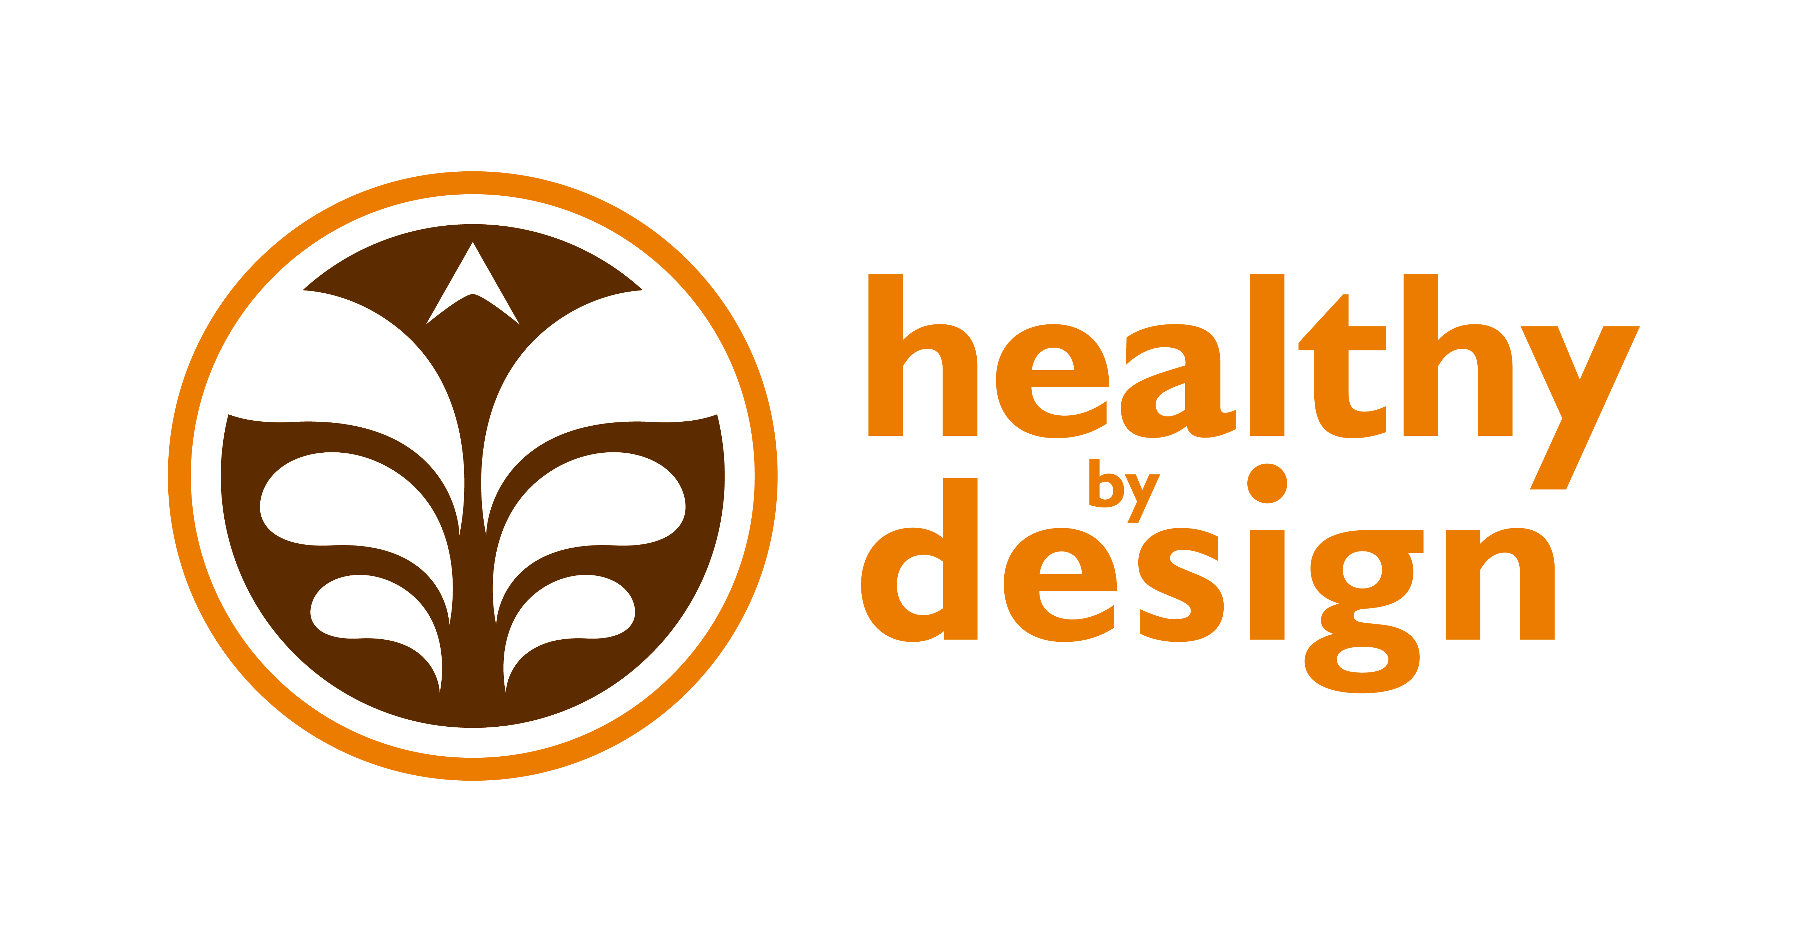

Coalition Partners

Creating a Community that is Healthy By Design
______________________________________________

November 5, 2013 Quarterly Meeting Notes

Attendees:

Alyssa Auvinen: RiverStone Health
Kristi Drake: BikeNet
Laura Holmlund: RiverStone Health
April Keippel: St. Vincent Healthcare
Jeanne Manske: Billings Clinic
Ginny Mermel: School Health Advisory Council
Hannah Silveus: RiverStone Health
Melissa VanderVos: RiverStone Health
Ron Wenger: MET Transit
Claire Oakley: RiverStone Health
Dasheema Jarrett: RiverStone Health
Shawn Hinz: RiverStone Health
Kate Hagenbuch: Billings Clinic
Colin Dow: St. Vincent Healthcare
Heather Fink: Healthy By Design/ The Alliance
Angela Douglas:
Juliet Spalding: City- County Planning
Debra Hagel: MET Transit

Announcements:
Kristi: BikeNet Membership Drive is Thursday, Nov. 14th from 6-8 at Yellowstone Cellars and
Winery. BikeNet is currently at 175 members and wants to hit 250 during this event. Please RSVP
at BikeNet.org if you plan to attend.
Ginny: Billings Action For Healthy Kids (BAFHK) has held PIR days for health enhancement
teachers in School District 2. These PIR days include information about nutrition, physical activity,
overall wellness and the academic connection. The last PIR day is scheduled for November 26th.
Shawn: Shawn and Debbie attended a meeting last weekend that recognized the importance of
collaborations. Shawn wanted to acknowledge that HBD is the highlighted health collaboration in
our community!
Heather: Welcome to the Community Health Improvement Coordinator (CHIC). This is a new
position paid for by the Alliance organizations for the purpose of improving health outcomes in the
community. Heather worked at the St. Vincent Healthcare Foundation for 6 years before accepting
this position.
Jeanne: The Community Health Needs Assessment (CHNA) is currently underway. If you receive a
phone call, please take 20 minutes to respond. These surveys help decide what health-related
initiatives in the community are a priority. The results will be shared with Coalition Partners in the
beginning of 2014.

Workgroup Reports:

Health Equity Workgroup – Co-Leads April Keippel & Shawn Hinz
Office on Women’s Health Project
- 9 Active Living Every Day (ALED) classes will continue 12/15/13, 62 people are registered.
- Classes will begin again February 2014.
- 5-2-1-0 social marketing campaign will begin soon.
Gardeners’ Market
- Went well this year! There was an average of 149 customers, 11 vendors per week, over $590 per week in sales.
- Considering change of location for 2014 season
- Will add SNAP benefits for next year.

Health Equity workgroup is meeting Thursday, November 14th, 3-4pm at Mansfield Health Education Center if any coalition partners want to join.

Healthy Weight Workgroup – Co-Leads Elizabeth Ciemins & Alyssa Auvinen
- Looking for primary care providers who are interested in presenting on motivational interviewing. Dr. Westmark at RiverStone Health has agreed to present to groups.
- HBD and 5-2-1-0 message has a presence at the Health Enhancement PIR days. Resources are available on the HBD website for teachers (and others).
- Jeanne mentioned that more Big Sky Fit Kids $1,000 grants are available for schools in the state.
- More coalition partners are always welcome to the group.

Built Environment Workgroup – Co-Leads Laura Holmlund & Luke Kobold
- The Complete Streets Benchmark report is available for review—coalition partners were given an executive summary of the report. Laura went through a presentation about what that report includes (e.g. bike/pedestrian counts, info on infrastructure projects, housing/transportation affordability index etc.). Report is available at: www.healthybydesignyellowstone.org and www.ci.billings.mt.us/transportationplanning.
- Workgroup members have presented to multiple boards/committees about the report. Ron mentioned that the follow-up report/presentations are very well received by the boards/committees because it allows for evaluation of an implemented policy.
- Billings Long Range Transportation Plan: visit http://billingslrtp.com –there is an interactive map that you can put comments on about what transportation projects you would like to see in Billings.
- Hannah reported on the Community Transportation Enhancement Program (CTEP) bike/pedestrian safety campaign sponsored by Healthy By Design. Television advertisement reached 84.5% of adults in Yellowstone County (28 views per adult) and radio advertisement reached over 57% of adults.

Worksite Wellness Workgroup – Co-Leads Dasheema Jarrett & Colin Dow
- Dasheema and Colin are the new Worksite Wellness co-leads!
- Scheduling presentations to reach out to businesses that may be interested in adopting worksite nutrition/physical activity guidelines. Presented at the Downtown Exchange club in October.
- Ginny is training other workgroup members on how a worksite assessment (how to use the nutrition and physical activity guidelines to help organizations make a healthier work environment). If any other businesses you know what an assessment let Dasheema and Colin know.
- The group will be updating the work plan and is looking for more members.

Recognition Program Workgroup – Co-Leads Kate Hagenbuch & April Keippel
- Kate and April are the new Recognition Program co-leads!
- The Recognition Program hadn’t met since May—but they will be working on revising the work plan and updating event recognition materials.
- The group is looking for another Physical Activity Reviewer—if know someone who would want to help review application please send information to Kate and April.

Next Coalition meeting
Tuesday, February 4th from 12–1:30pm
in the Yellowstone Room of the Lil Anderson Center
at RiverStone Health

